Low-Power Circuits for a 2.5-V, 10.7-to-86-Gb/s Serial Transmitter in 130-nm SiGe BiCMOS

Timothy O. Dickson^{1,2}, (Member, IEEE) and Sorin P. Voinigescu¹, (Senior Member, IEEE)

1. The Edward S. Rogers, Sr. Department of Electrical and Computer Engineering
University of Toronto, 10 King’s College Road, Toronto, Ontario, M5S 3G4, Canada

2. Now with IBM T.J. Watson Research Center
1101 Kitchawan Road MS 40-141, Yorktown Heights, NY

Tel: (914) 945-2325, Fax (914) 945-1974, email: todickso@us.ibm.com

Abstract
Low-power building blocks for a serial transmitter operating up to 86 Gb/s are design and implemented in a 130-nm SiGe BiCMOS technology with 150-GHz f_{T} SiGe HBT. Design techniques are presented which aim to minimize high-speed building block power consumption. They include lowering the supply voltage by employing a true BiCMOS high-speed logic family, as well as reducing current consumption by trading off tail currents for inductive peaking. A serial transmitter testchip consuming under 1W is fabricated and operation is verified up to 86-Gb/s at room temperature (92Gb/s and 71 Gb/s at 0ºC and 100ºC, respectively). The circuit operates from a 2.5-V supply voltage, which is the lowest supply voltage for circuits at this data rate in silicon technologies reported to date.
Index Terms – Serial transmitter, SiGe HBT, BiCMOS, CML, multiplexer, inductors, Colpitts VCO, 100G Ethernet
I. Introduction
The volume of data transported over networks continues to increase, fueled by demands for faster transmission of bandwidth-intensive applications such as high-definition video broadcasts. Next generation serial communication systems are expected to have data rates in the 80-100 Gb/s range, as evidenced by recent calls for 100-Gb/s Ethernet (100GE). As a result, high-speed building blocks such as multiplexers, demultiplexers, and clock and data recovery circuits have been reported in the literature operating at data rates of at least 80 Gb/s and implemented primarily in SiGe HBT or InP HBT technologies [1-3]. To achieve such high data rates with time-division multiplexing techniques, building block power consumption is often considerably high. For example, 4:1 multiplexers operating above 100-Gb/s dissipate at least 1.4W even in HBT technologies with transistor cutoff frequencies exceeding 200 GHz [1]. Such numbers do not bode well for the integration of a single-chip 100GE serializer-deserializer (SERDES). Moreover, a state-of-the-art 10GE SERDES in 130-nm CMOS consumes only 800mW [4], indicating that a more power efficient 100GE solution could be realized by operating ten 10GE channels in parallel. However, the latter solution increases system complexity. If single-chip 100GE SERDES are to be feasible, power consumption must be lowered in HBT-based transceivers.
This paper presents low voltage, low power design techniques for high speed wireline building blocks. Power dissipation is minimized by employing a low 2.5-V supply voltage, while using inductive peaking to lower bias currents in high-speed building blocks. As a test vehicle to show how record-breaking performance can be achieved with low power consumption, a 2.5-V, 10.7-to-86-Gb/s serial transmitter is designed in a 130-nm SiGe BiCMOS technology with HBT f_{T} = 150 GHz. The paper is organized as follows. Section II presents low-power design methods for high-speed digital building blocks. These concepts are then applied to the design of critical building blocks for an 86-Gb/s serial transmitter in Section III. Key building blocks, including high-speed BiCMOS CML gates clocked at 43-GHz, an 86-Gb/s output driver with adjustable amplitude control, and a bipolar Colpitts oscillator are discussed. Experimental verification of the test chip is presented in Section IV. Finally, Section V concludes the paper.

II. Low-Power High-Speed Design Methodology
In order to reduce power consumption in high-speed digital building blocks, one must combat the problem on two fronts. First, the supply voltage must be lowered. This has been problematic in SiGe bipolar designs due to the high V_{BE} of the HBT, leading to power supplies of 3.3V or 5V irrespective of technology node. In CMOS technologies constant-field scaling has allowed for a continued reduction in supply voltage with each new technology, leading to 1-V power supplies in 90-nm technologies. It has been demonstrated that one can derive a logic family that employs both n-channel MOSFETs and SiGe HBTs in a BiCMOS technology. A BiCMOS inverter from this logic family is illustrated in Fig 1(a), which maintains the high intrinsic slew rate of the SiGe HBT while employing MOSFETs on lower-level transistors to benefit from its low input time constant [5]. At the 130-nm technology node and below, the V_{GS} of the nMOS (~750mV) is lower than the V_{BE} of the SiGe HBT (~900mV) when both devices are biased at their peak f_{T} (Figure 2). Unlike previous attempts to replace HBTs with n-MOSFETs for low-voltage operation of CML/ECL digital gates at the 0.8-μm technology node [6] (where the MOSFET V_{GS} at peak-f_{T} is at least 3V), it is now possible to do so while still getting the best high-speed performance from the n-channel device. The resulting 2.5-V power supply of this logic family represents a 24% reduction in power consumption as compared with 3.3-V bipolar current-mode logic blocks without compromising speed. Moreover, it has been shown that by removing current tail transistors from the BiCMOS logic topology, the supply voltage can be further lowered to 1.8V. Early evidence suggests that the combination of 130-nm MOSFETs with 230-GHz f_{T} HBTs from a 1.8-V supply will result in a lower-power 80-Gb/s latch than one implemented in 65-nm LP CMOS operating from 1.2V [7]. Such results not only testify to the potential of BiCMOS logic for low-power serial transceiver design, but also demonstrate that it may be a more economical solution than moving to highly-scaled CMOS technologies.
It is important to distinguish the BiCMOS logic family from other low-voltage topologies which rely on the parallel switching of bipolar transistors to reduce device stacking [8]. These topologies require double the number of tail current sources, but since the supply voltage is not reduced by half the power dissipation per building block actually increases. This distinction points to a second goal in reducing power dissipation, which is to minimize the bias current in each building block. To first-order, the bandwidth of the resistively-loaded BiCMOS inverter in Figure 1(a) is set by the time constant at the output node.
${\text{BW}}_{3\text{dB}}≈\frac{1}{2π×R_{L1}×C_{L}}=\frac{I_{T1}}{2π×ΔV×C_{L}}$ . (1)
Here, C_{L} represents the total capacitance at the output node. It is well-known that for a fixed resistance, one can add inductive peaking and improve bandwidth by as much as 60%. Alternatively one can design for lower bandwidth with larger load resistances, and then apply inductive peaking to reach the desired 3-dB bandwidth. The bandwidth of the BiCMOS cascade inverter with inductive peaking in Figure 1(b) becomes
${\text{BW}}_{3\text{dB},\text{peaked}}≈1\text{.}6×\frac{1}{2π×R_{L2}×C_{L}}=1\text{.}6×\frac{I_{T2}}{2π×ΔV×C_{L}}$ . (2)
Setting the bandwidths of (1) and (2) to be equal and noting that the logic swing ΔV remains constant, one can see that the bias current after peaking is about 37% lower than the design without peaking. In a BiCMOS implementation with a 2.5-V supply, the total power consumption after applying inductive peaking is slightly less than half that of a 3.3-V bipolar design without inductive peaking. One perceived drawback of this approach is the area occupied by the inductors. This can be mitigated by using the multiple metal layers available in CMOS or BiCMOS technologies and create stacked (or 3D) structures to obtain a larger inductance for a given area, as shown in Figure 3 [9]. It is important to note that like MOSFETs, spiral inductors also follow scaling laws. One can estimate the inductance L of a 3D spiral constructed from m metal layers based on the number of turns n, outer diameter d and average diameter d_{avg} [10, 11].
$L≈\frac{6μ_{0}m^{2}n^{2}d_{\text{avg}}^{2}}{\text{11}d−7d_{\text{avg}}}$ . (3)
From (3), it is observed that if the diameter is scaled by a factor S, the inductance also reduces by the same factor.
$\frac{L}{S}≈\frac{6μ_{0}m^{2}n^{2}{\left(d_{\text{avg}}S\right)}^{2}}{\left(1S\right)\left(\text{11}d−7d_{\text{avg}}\right)}$ . (4)
Moreover, the oxide capacitance from the bottom metal layer to the substrate is a function of the total metal line length in one layer (l), the trace width (W), and the distance from the bottom metal layer to the substrate. If the length and width are scaled by the same factor S, the inductor area is reduced by a factor of S², as is the parasitic capacitance to ground.
$C_{\text{OX}}≈\frac{1}{2}\text{lW}\frac{ε_{\text{OX}}}{h}⇒\frac{C_{\text{OX}}}{S^{2}}≈\frac{1}{2}\left(\frac{l}{S}\right)\left(\frac{W}{S}\right)\frac{ε_{\text{OX}}}{h}$ . (5)
This suggests that it is reasonable to integrate a large number of inductors on a single-chip, particularly at high frequencies where the required inductance value is not large. In the design to be presented in Section III, stacked inductors can be realized with outer diameters of between 10μm and 20μm. Interestingly, this is on the same order as the gate widths of the MOSFETs employed in 80-Gb/s logic circuits. The inductor quality factor is not of particular importance in shunt-peaking peaking applications, as it can be absorbed in the resistive load. However for completeness is it instructive to see how Q scales with the inductor size. The DC resistance in a single metal layer can be determined by introducing the metal thickness t and sheet resistance ρ.
$R_{\text{DC}}≈\frac{ρl}{\text{Wt}}⇒R_{\text{DC}}≈\frac{ρ\left(\frac{l}{S}\right)}{\left(\frac{W}{S}\right)t}$ . (6)
While l and W are both reduced by S, the metal thickness and sheet resistance cannot be changed and the total series resistance remains constant. The same is true at high frequencies when the skin depth δ of the conductor is considered.
$R_{\text{AC}}≈\frac{ρl}{Wδ\left[1−\text{exp}\left(\frac{−t}{δ}\right)\right]}⇒R_{\text{AC}}≈\frac{ρ\left(\frac{l}{S}\right)}{\left(\frac{W}{S}\right)δ\left[1−\text{exp}\left(\frac{−t}{δ}\right)\right]}$ . (7)
Because of this the peak quality factor of the scaled inductor is unchanged, but at a frequency S times higher. Consequently spiral structures are as suitable for use at mm-wave frequencies above 30 GHz as they were for RF applications at 2 GHz.

III. 80-Gb/s Serial transmitter Design
Using the low-power design techniques presented in Section II, an 80-Gb/s serial transmitter testchip was designed in a 130-nm SiGe BiCMOS technology with 150-GHz f_{T} HBTs. The block diagram of the transmitter is shown in Figure 4. It consists of an 86-Gb/s 8:1 multiplexer (MUX), an 86-Gb/s output driver with adjustable amplitude control, and a 43-GHz 16:1 frequency divider. Additionally, a low-power 10.7-Gb/s 2⁷-1 PRBS generator is also included for built-in self-test [12]. For testing purposes, the 8 inputs to the MUX were aligned such that the 86-Gb/s output would also be pseudo-random.
The 8:1 MUX is implemented by connecting several 2:1 multiplexers in a tree architecture. A block diagram of the final 2:1 multiplexer is shown in Figure 5 and consists of five 43-GHz latches which align the data going into the 86-Gb/s selector. Note that the lower speed 2:1 multiplexers employ the same 5-latch architecture. The BiCMOS implementation of a 43-GHz latch using the low power techniques outlined in Section II is illustrated in Figure 6. Compared with our previous latch designs [5], the use of level-shifting followers in the latch regenerative path has been removed for further power savings. The power consumption of the 43-GHz latch is 20mW, which is believed to be the lowest for any silicon-based latch operating at this speed and equals that of the lowest-power InP HBT latch [13].
The schematic of the BiCMOS 86-Gb/s selector is shown in Figure 7. A combination of MOS source followers and HBT emitter followers are employed on the data and clock paths, respectively. The latter have higher bandwidth, making them more suitable for use on the 43-GHz clock path. Headroom considerations prevent the use of HBT followers on the input data paths if the circuit is to operate from 2.5V. Instead, MOS source followers are employed on the 43-Gb/s input data paths. It is interesting to note that the combination of MOS and HBT devices on high speed paths gives rise to important DC biasing considerations. Of primary concern is the V_{DS} of transistors M₁ and M₂ in the selector. If the data and clock signals at the input to the source followers have the same common mode level, it can be seen that the V_{DS} of both M₁ and M₂ at the quiescent point is nearly zero. This results in a significant degradation in the f_{T} of the MOSFETs and prevents the devices from switching at the required 43-GHz clock rate. To avoid this situation, a common-mode resistor is inserted in the clock buffer as seen in Figure 8. The voltage drop across this resistor sets the V_{DS} of M₁ and M₂ to ensure sufficient f_{T} for 43-GHz operation.
The 86-Gb/s selector is followed by a 50-Ω output driver with adjustable amplitude control whose schematic is presented in Figure 9. The final stage of the driver consists of a BiCMOS cascade differential pair, which combines the excellent input linearity of the n-channel MOSFET with the output linearity of a bipolar transistor. A key advantage of this implementation is that unlike bipolar transistors, the transconductance and input capacitance of an n-channel MOSFET biased near its peak-f_{T} current density of 0.3mA/μm remain fairly constant as a function of the bias current [14]. Consequently as the tail current in the differential pair is varied to adjust the output swing, little degradation in the quality of the output eye diagram is observed. Measured S-parameters of a breakout of this driver were presented previously [14], which show that the output match is unaffected by the change of bias current. Intentional gain peaking at higher frequencies is introduced to compensate for losses in the cables and probes anticipated in the measurement setup. Note that the 130-nm nMOSFETs with f_{T} = 85GHz switch at the full-rate of 86-Gb/s, the fastest for any MOSFET digital circuit reported to date.
At data rates above 40 Gb/s, low noise clock generation becomes evermore critical to minimize jitter in transmitted data. This underscores the need for low phase noise VCOs. While the use of cross-coupled VCOs is widespread, it is important to realize that the output directly loads the LC tank and leads to lower tuning range and higher phase noise. On the other hand, the Colpitts common-collector VCO topology does not suffer from such limitations. A schematic of a bipolar Colpitts oscillator is illustrated in Figure 10. The tank is formed around the base-emitter of the SiGe HBTs, with the capacitance in the emitter providing sufficient negative resistance to sustain oscillations. The output is taken from the collector resulting in improved isolation. Differential tuning is achieved through the use of accumulation-mode nMOS varactors, as can be seen in the schematic. It is noted that the base-to-collector capacitance loads the tank and degrades the oscillator tuning range. To compensate for C_{BC}, cross-coupled neutralization capacitors are introduced [15]. Unlike similar VCOs which combine the Colpitts and cross-coupled topologies [16], it is important to note that these capacitors do not impact the oscillation frequency. It can be shown that the oscillation frequency is given by
$f_{\text{osc}}=\frac{1}{2π\sqrt{L_{B}C_{\text{EFF}}}}$ (8)
where the effective tank capacitance is
$C_{\text{EFF}}≈C_{\text{BC}}−C_{N}+\frac{\left(C_{1}+C_{\text{BE}}\right)\left(C_{\text{VARP}}+C_{\text{VARN}}\right)}{C_{1}+C_{\text{BE}}+C_{\text{VARP}}+C_{\text{VARN}}}$ (9)
Clearly for C_{N} equal to C_{BC}, the impact of the base-to-collector capacitance is cancelled. Interestingly, simulations in Figure 11 show that the phase noise of the 40-GHz VCO is minimized for C_{N} = C_{BC}.

IV. Experimental Results
The transmitter IC and associated test structures were fabricated in a 130-nm SiGe BiCMOS technology with SiGe HBT f_{T} of 150 GHz [17]. A separate VCO test structure was also fabricated and measured on-die using an Agilent E4448A PSA and E4419B power meter with DC-to-50-GHz power sensor. The VCO tuning range and output power are depicted in Figure 12, showing that the VCO is tunable from 36.7-42.7 GHz (15.1%) at room temperature. The oscillation frequency remains remarkably constant over temperatures from 25ºC to 100ºC, which is a direct result of employing a tank which does not rely on base-to-emitter capacitances to set the oscillation frequency. MOS varactors are used instead of p-n varactors. Additionally, capacitor C₁ is dominated by a MIM capacitor instead of the C_{BE} of the tank transistor. The measured phase noise is about -103 dBc/Hz at a 1-MHz offset as seen in Figure 13. It is pointed out that the measured phase noise is lower than the value simulated in Figure 11, a fact that is not uncommon in high frequency HBT VCOs [18] and is attributed to the lack of correlation between the base and collector noise current sources in existing BJT/HBT models [19]. The differential VCO consumes 20mA from a 2.5-V supply.
The die photo of the transmitter IC is shown in Figure 14 and measures 1.5mm x 1.8mm. The transmitter includes an on-chip 40-GHz clock multiplier unit (CMU) which is tunable from 38 to 42 GHz. Due to higher-than-expected PLL noise, the CMU jitter is too high and the transmitter was tested using an external 40-GHz clock. All measurements were performed on-die with a temperature-controlled probe station. Time domain measurements were performed with an Agilent 86100C DCA with 86107A 40-GHz precision timebase and 86118A 70-GHz remote sampling heads. Figures 15 and 16 depict 80-Gb/s single-ended output eye diagrams with 300-mV and 100-mV per side, respectively, demonstrating a 3:1 variation in output amplitude without degrading the eye quality. Two methods were employed to verify correct multiplexing of the input PRBS sequence. First, the output sequence was captured on the DCA and compared with the ideal 2⁷-1 sequence, as seen in Figure 17. Additionally as PRBS sequences are periodic, the sequence length can be determined by examining tone spacing in the output power spectrum as seen in Figure 18. Figure 19 depicts the single-ended eye diagram at the maximum data rate of 86 Gb/s at room temperature. The temperature dependence on the maximum operating data rate is shown in Figure 20. The transmitter is functional up to 71 Gb/s at 100ºC and 92 Gb/s at 0ºC, as seen in Figure 21.
The total power dissipation is 996mW from a 2.5-V supply, and breaks down as follows: 372 mW for the 8:1 MUX, 172mW for the output driver, 85mW for the 16:1 frequency divider, 222mW for the clock distribution, and 145mW for the on-chip 2⁷-1 PRBS generator. If the 360mW from the PLL is also considered, this work demonstrates that an entire 80-Gb/s transmitter can be realized with a power dissipation of about 1.4W. A comparison with other high-speed transmitters in various semiconductor technologies [20-22] is presented in Table I. The 80-Gb/s transmitter in this work achieves lower power dissipation than any 40-Gb/s transmitter reported to date. Comparing with state-of-the-art CMOS results at the same lithography node [20], this work shows that by adding a SiGe HBT to a CMOS process one can achieve a serial transmitter with double the data rate with dissipating half of the power.

VI. Conclusion
Low-power design techniques for high-speed building blocks have been presented, allowing for record-breaking performance with low power consumption. Power dissipation is minimized at the building block level by using a low (2.5-V) supply voltage and by trading off bias current for inductive peaking. To demonstrate these low power techniques, all of the critical high-speed building blocks for an 86-Gb/s serial transmitter have been designed and verified. To the authors’ best knowledge, this marks the lowest supply voltage for circuits at such high data rates in silicon-based technologies. The low power consumption suggests that an entire serial transmitter with CMU operating at 80-Gb/s is feasible with a power consumption of 1.4W. Finally by applying the presented design techniques in more advanced SiGe BiCMOS technologies with cutoff frequencies in excess of 200 GHz [23], low power single-chip transceivers for 100G Ethernet can be realized.

Acknowledgment
The authors gratefully acknowledge Bernard Sautreuil, Pascal Chevalier, and STMicroelectronics Crolles for fabrication and support. Measurement equipment was made possible through grants from Canada Foundation for Innovation (CFI) and Ontario Innovation Trust (OIT). The authors would like to thank Gennum Corporation and the Centre for Communications and Information Technology Ontario (CITO) for financial support. CAD tools and support were provided by the Canadian Microelectronics Corporation (CMC) and Jaro Pristupa. Finally, measurement assistance provided by Theodoros Chalvatzis and Ricardo Aroca is greatly appreciated.

References
[1] M. Meghelli, “A 132-Gb/s 4:1 multiplexer in 0.13-μm SiGe-bipolar technology,” IEEE J. Solid-State Circuits, vol. 39, no. 12, pp. 2403-2407, December 2004.
[2] J. Hallin, T. Kjellberg, and T. Swahn, “A 165-Gb/s 4:1 multiplexer in InP DHBT technology,” IEEE J. Solid-State Circuits, vol. 41, no. 10, pp. 2209-2214, October 2006.
[3] R. E. Makon, R. Driad, K. Schneider, M. Ludwig, R. Aidam, R. Quay, M. Schlechtweg, and G. Weimann, “InP DHBT-based monolithically integrated CDR/DEMUX IC operating at 80 Gbit/s,” IEEE J. Solid-State Circuits, vol. 41, no. 10, pp. 2215-2223, October 2006.
[4] S. Sidiropoulos, N. Acharya, P. Chau, J. Dao, A. Feldman, H.-J. Liaw, M. Loinaz, R. S. Narayanaswami, C. Portmann, S. Rabii, A. Salleh, S. Sheth, L. Thon, K. Vleugels, P. Yue, and D. Stark, “An 800-mW 10Gb Ethernet transceiver in 0.13μm CMOS”, IEEE ISSCC Dig. Tech. Papers, pp. 168-169, 2004.
[5] T. O. Dickson, R. Beerkens, and S. P. Voinigescu, “A 2.5-V 45-Gb/s decision circuit using SiGe BiCMOS logic,” IEEE J. Solid-State Circuits, vol. 40, no. 4, pp. 994-1003, April 2005.
[6] O. Kromat and U. Langmann, “Application of merged current switch logic for a built-in logic block observer operating at 1Gbit/s and 1.2V supply,” Elec. Letters, pp. 2111-2113, Dec. 1997.
[7] P. Chevalier, D. Gloria, P. Scheer, S. P. Voinigescu. T. O. Dickson, E. Laskin, S. T. Nicolson, T. Chalvatzis, K. H. K. Yau, S. Pruvost, F. Gianesello, F. Pourchon, P. Garcia, J.-C. Vildeuil, A. Chantre, C. Garnier, and O. Noblanc, “Advanced SiGe BiCMOS and CMOS platforms for optical and millimeter-wave integrated circuits,” IEEE Comp. Semiconductor IC Symp. Tech. Dig., pp. 12-15, 2006.
[8] B. Razavi, Y. Ota, and R. G. Schwartz, “Design techniques for low-voltage high-speed digital bipolar circuits,” IEEE J. Solid-State Circuits, vol. 29, no. 3, pp. 332-339, March 1994.
[9] T. O. Dickson, M.-A. LaCroix, S. Boret, D. Gloria, R. Beerkens, and S. P. Voinigescu, “30-100 GHz inductors and transformers for millimeter-wave (Bi)CMOS integrated circuits” IEEE Trans. Microwave Theory and Techniques, vol. 53, no. 1, pp. 123-133, January 2005.
[10] T. H. Lee, The Design of CMOS Radio-Frequency Integrated Circuits, 2nd Ed. New York: Cambridge University Press, 2004.
[11] A. Zolfaghari, A. Chan, and B. Razavi, “Stacked Inductors and Transformers in CMOS Technology,” IEEE J. Solid-State Circuits, vol. 36, no. 4, pp.620-628, April 2001.
[12] E. Laskin and S. P. Voinigescu, “A 60mW per lane, 4 x 23-Gb/s 2⁷-1 PRBS generator,” IEEE J. Solid-State Circuits, vol. 41, no. 10, pp. 2198-2208, October 2006.
[13] Y. Amamiya, Y. Suzuki, J. Yamazaki, A. Fujihara, S. Tanaka, and H. Hida, “1.5-V low supply voltage 43-Gb/s delayed flip-flop circuit,” IEEE GaAs IC Symp. Tech. Dig., pp. 169-172, 2003.
[14] T. O. Dickson, K. H. K. Yau, T. Chalvatzis, A. M. Mangan, E. Laskin, R. Beerkens, P. Westergaard, M. Tazlauanu, M.-T. Yang, and S. P. Voinigescu, “The invariance of characteristic current densities in nanoscale MOSFETs and its impact on algorithmic design methodologies and design porting of Si(Ge) (Bi)CMOS high-speed building blocks,” IEEE J. Solid-State Circuits, vol. 41, no. 8, pp. 1830-1845, August 2006.
[15] S. T. Nicolson, K. H. K. Yau, K. A. Tang, P. Chevalier, A. Chantre, B. Sautreuil, “Design and scaling of SiGe BiCMOS VCOs above 100 GHz,” Proc. IEEE BCTM, pp. 142-145, 2006.
[16] J.-C. Chien and L.-H. Lu, “40GHz wide-locking-range regenerative frequency divider and low-phase-noise balanced VCO in 0.18μm CMOS”, IEEE ISSCC Dig. Tech. Papers, pp. 544-545, 2007.
[17] M. Laurens, B. Martinet, O. Kermarrec, Y. Campidelli, F. Deleglise, D. Dutartre, G. Troillard, D. Gloria, J. Bonnouvrier, R. Beerkens, V. Rousset, F. Leverd, A. Chantre, and A. Monroy, “A 150 GHz f_{T}/f_{MAX} 0.13 μm SiGe:C BiCMOS technology”, Proc. IEEE BCTM, pp. 199-202, 2003.
[18] C. Lee, T. Yao, A. Mangan, K. Yau, M. A. Copeland, and S.P. Voinigescu, “SiGe BiCMOS 65-GHz BPSK transmitter and 30 to 122 GHz LC-varactor VCOs with up to 21% tuning range,” IEEE Comp. Semiconductor IC Symp. Tech. Dig., pp. 179-182, 2004.
[19] K.H.K. Yau and S.P. Voinigescu, “Model extraction of SiGe HBT noise parameters from measured y-parameters and accounting for noise correlation,” 6th Topical Meeting on Silicon Monolithic ICs in RF Systems, pp. 226-229, 2006.
[20] J. Kim, J.-K. Kim, B.-J. Lee, M.-S. Hwang, H.-R. Lee, S.-H. Lee, N. Kim, D.-K. Jeong, and W. Kim, “Circuit techniques for a 40Gb/s transmitter in 0.13μm CMOS”, IEEE ISSCC Dig. Tech. Papers, pp. 150-151, 2005.
[21] A. Hendarman, E.A. Sovero, X. Xu, and K. Witt, “STS-768 multiplexer with full rate output data retimer,” IEEE GaAs IC Symp. Tech. Dig., pp. 211-214, 2002.
[22] M. Meghelli, “A 43-Gb/s full-rate clock transmitter in 0.18-μm SiGe BiCMOS,” IEEE J. Solid-State Circuits, vol. 40, no. 10, pp. 2046-2050, October 2005.
[23] P. Chevalier, C. Fellous, L. Rubaldo, D. Dutartre, M. Laurens, T. Jagueneau, F. Levard, S. Bord, C. Richard, D. Lenoble, J. Bonnouvrier, M. Marty, A. Perrotin, D. Gloria, F. Saguin, B. Barbalat, R. Beerkens, N. Zerounian, F. Aniel, and A. Chantre, “230-GHz self-aligned SiGeC HBT for 90nm BiCMOS technology,” Proc. IEEE BCTM, pp. 225-228, 2004.

Technology | f_{T}/f_{MAX} | Data rate | Supply Voltage | P_{DISS} | Ref.
130-nm CMOS | ~85/90 GHz | 40 (half-rate) | 1.5 V | 2.7 W | [20]
InP HBT | 150/150 GHz | 43 (full-rate) | -3.6/-5.2 V | 3.6 W | [21]
180-nm SiGe BiCMOS | HBT: 120/100 GHz | 43 (half-rate) | -3.6 V | 1.6 W | [22]
180-nm SiGe BiCMOS | HBT: 120/100 GHz | 43 (full-rate) | -3.6 V | 2.3 W | [22]
130-nm SiGe BiCMOS | MOS: 85/90 GHz  HBT: 150/160 GHz | 86 (half-rate) | 2.5 V | 1.4 W | This Work

Table I. Comparison of high-speed transmitter power dissipation in various technologies.

Dickson and Voinigescu
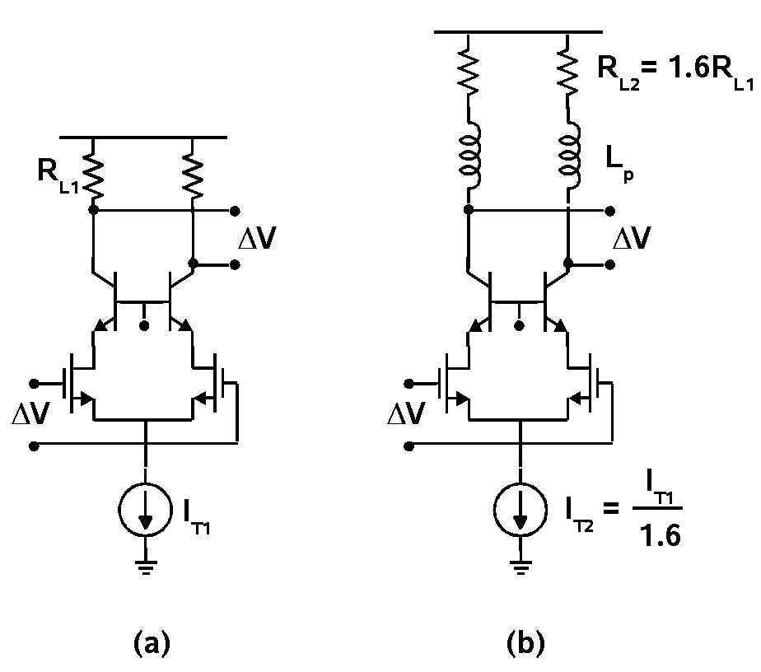

Figure 1. BiCMOS CML inverters (a) without and (b) with inductive peaking. The inverter in (b) achieves roughly the same 3-dB bandwidth as that in (a) but with lower bias current.

Dickson and Voinigescu
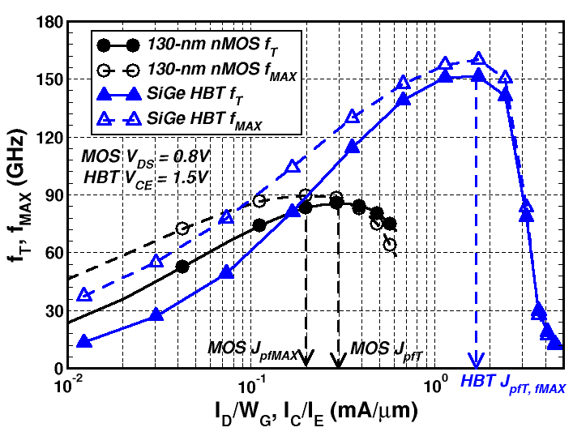

Figure 2. Measured f_{T} and f_{MAX} versus current density for 130-nm n-channel MOSFETs (finger width = 2μm) and SiGe HBTs.

Dickson and Voinigescu



Figure 3. Conceptual illustration of a stacked (or 3D) spiral inductor implemented in two metal layers.

Dickson and Voinigescu

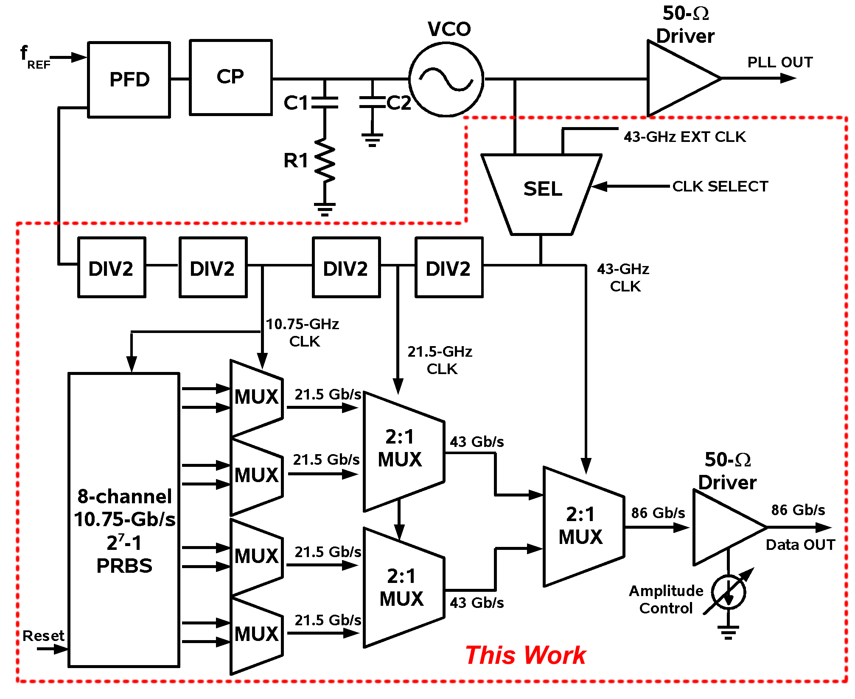

Figure 4. Block diagram of the 80-Gb/s transmitter IC testchip.

Dickson and Voinigescu

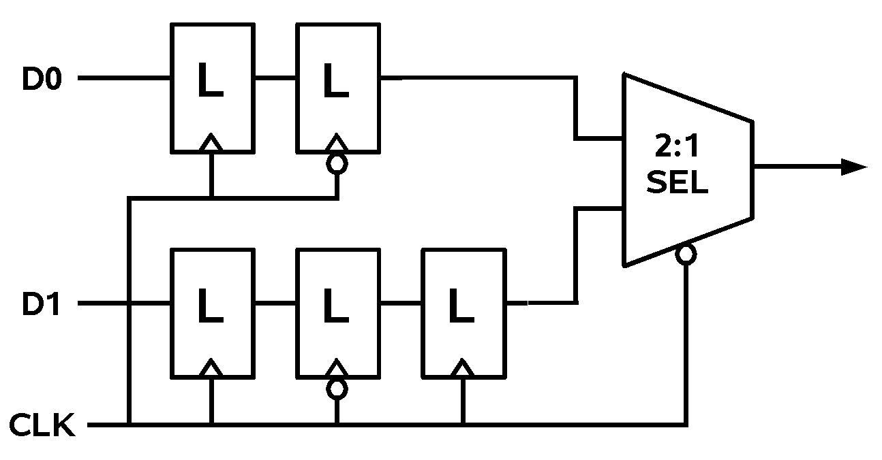

Figure 5. 2:1 MUX implementation with 5 latches and a selector.

Dickson and Voinigescu

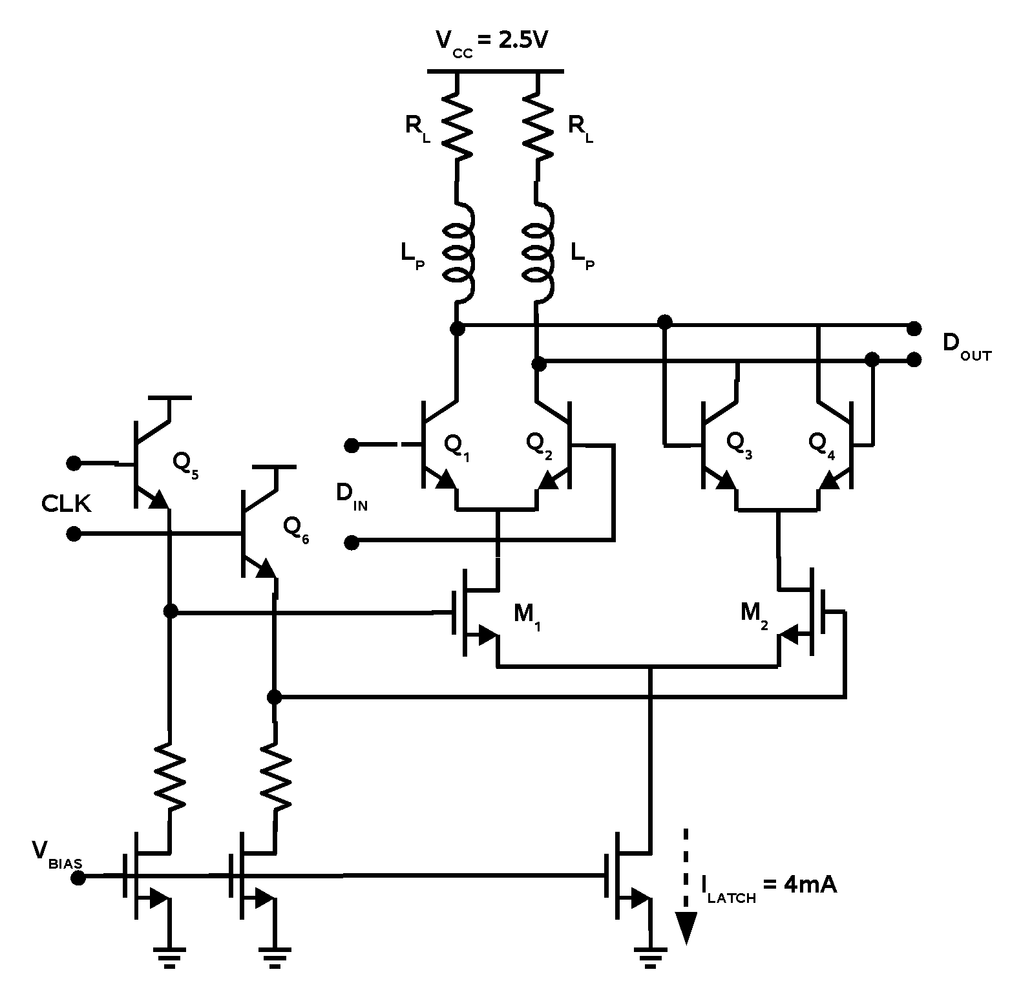

Figure 6. 20-mW, 43-Gb/s BiCMOS latch

Dickson and Voinigescu
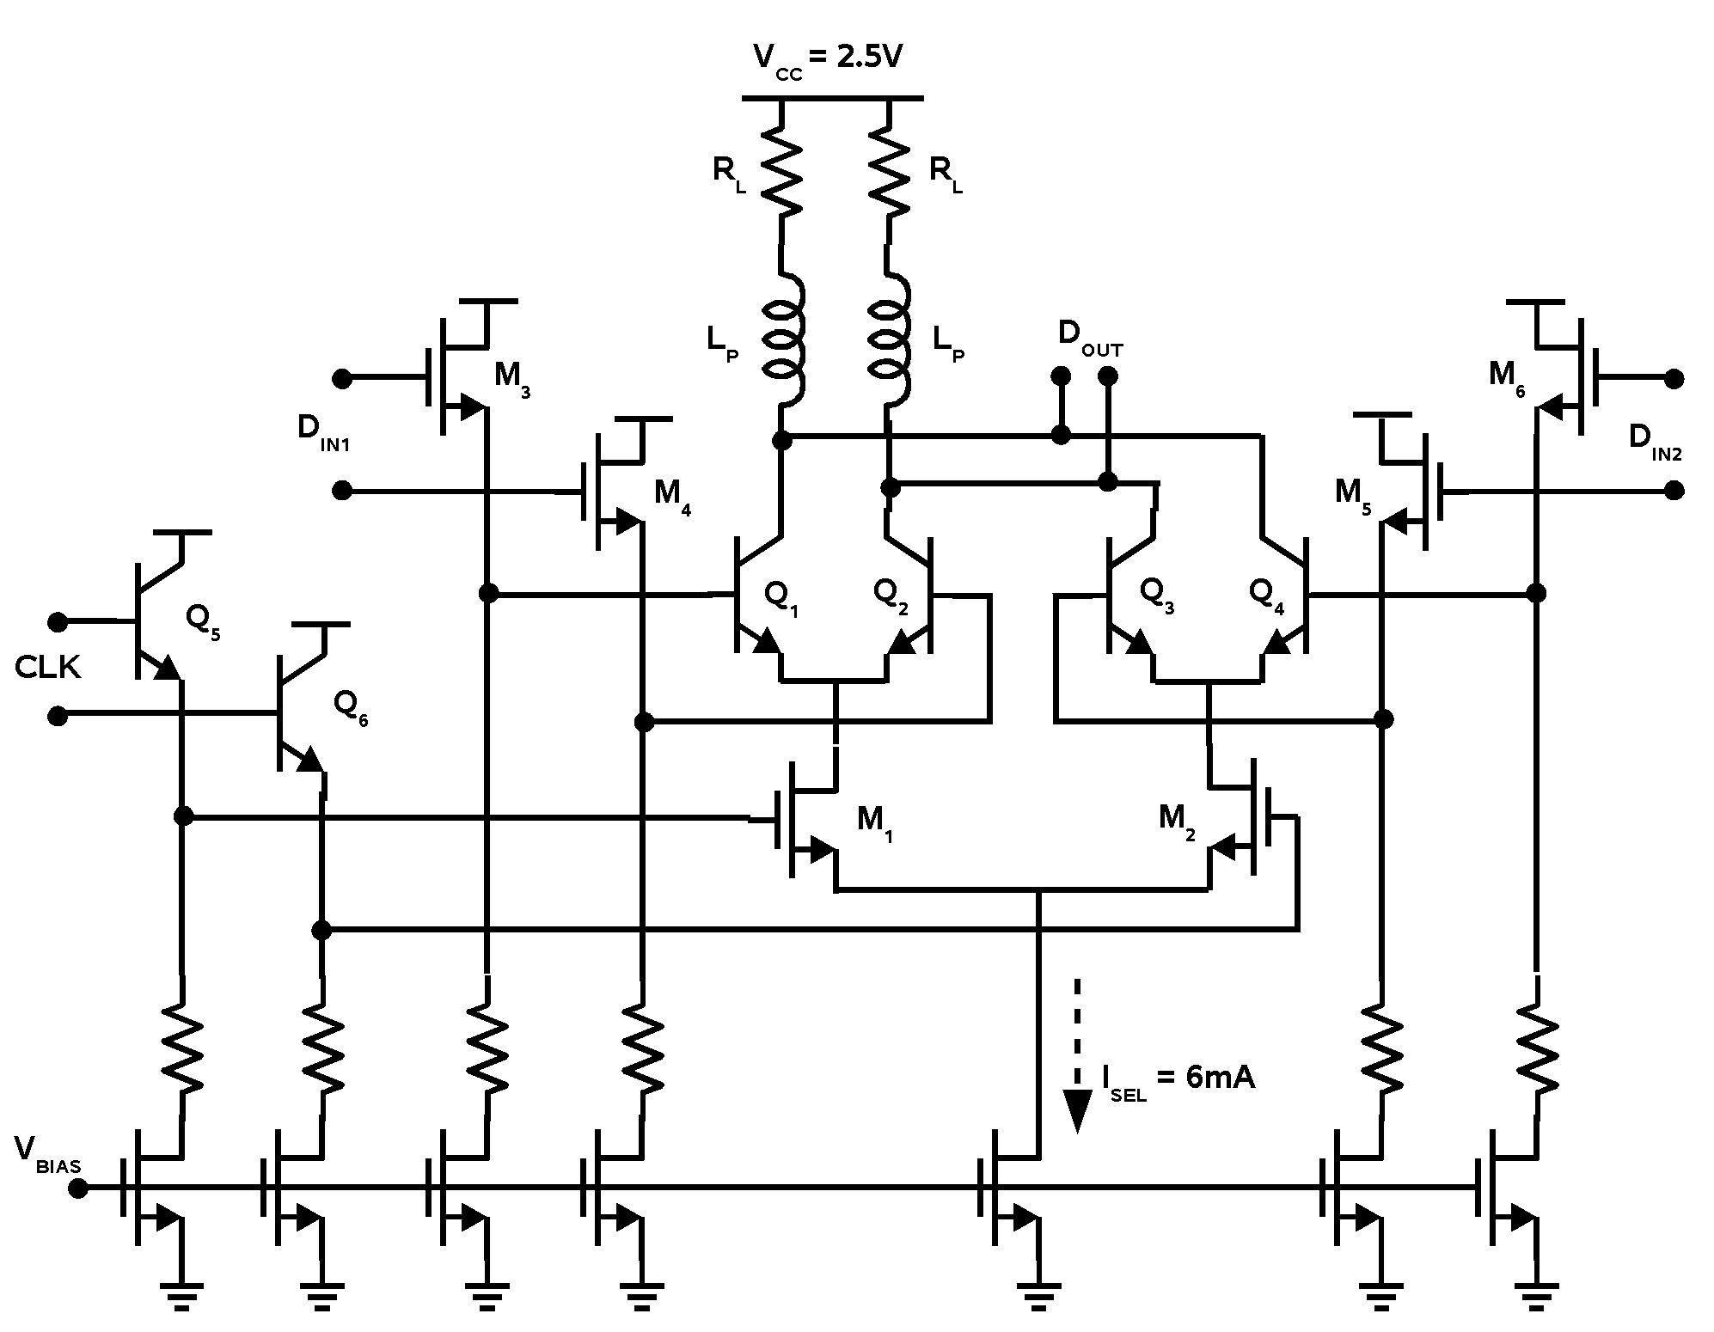

Figure 7. 60-mW. 86-Gb/s BiCMOS selector.

Dickson and Voinigescu

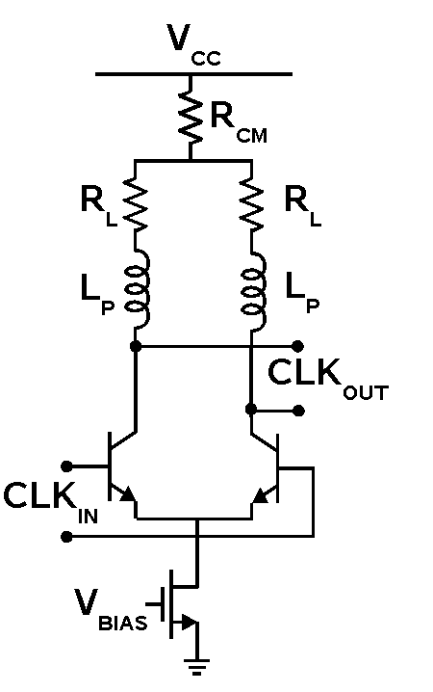

Figure 8. 43-GHz clock buffer. A common-mode resistor is employed to avoid operating nFETs M1/M2 from Figure 6 in the triode region.

Dickson and Voinigescu

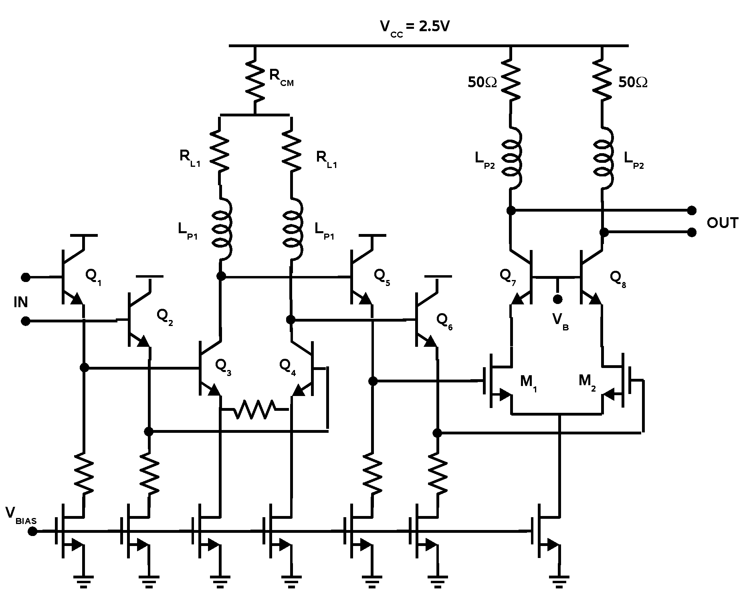

Figure 9. 86-Gb/s 50-Ω BiCMOS output driver with adjustable amplitude control.

Dickson and Voinigescu

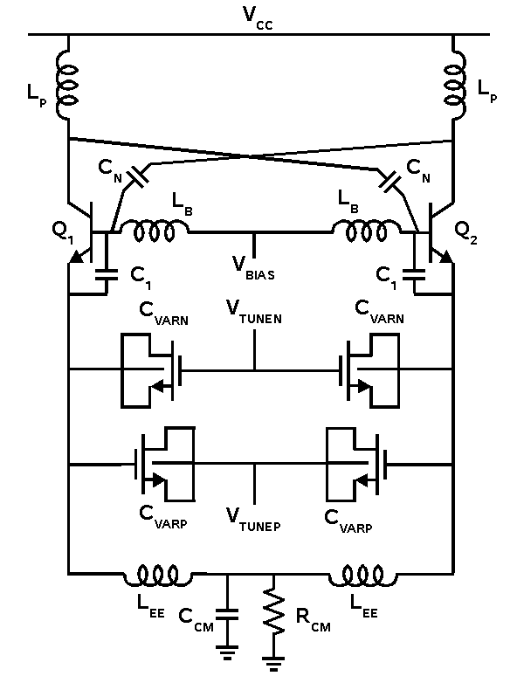

Figure 10. 40-GHz Colpitts common-collector oscillator with C_{BC} neutralization

Dickson and Voinigescu

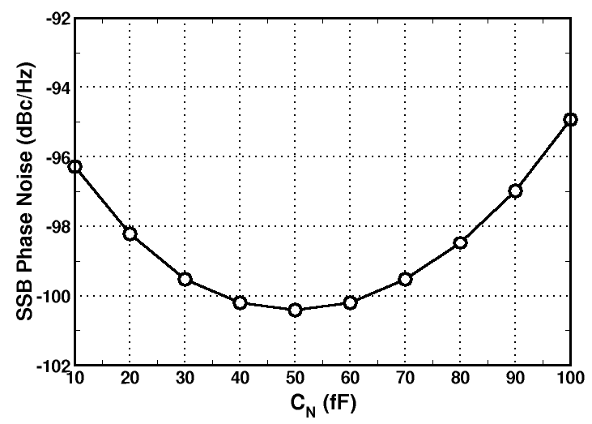

Figure 11. Effect of neutralization capacitor C_{N} on simulated phase noise at a 1-MHz offset from the 40-GHz center frequency. The phase noise is minimized when C_{N} equals C_{BC} of the tank transistors.

Dickson and Voinigescu

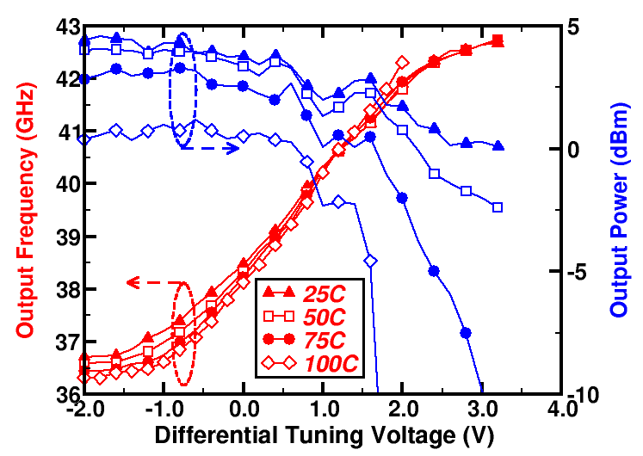

Figure 12. Measured tuning characteristics and output power of the 40-GHz Colpitts oscillator with differential tuning.

Dickson and Voinigescu

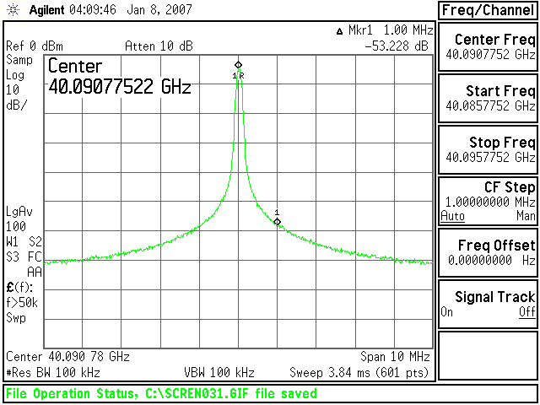

Figure 13. Measured 40-GHz VCO spectrum showing a phase noise of -103 dBc/Hz at a 1-MHz offset.

Dickson and Voinigescu

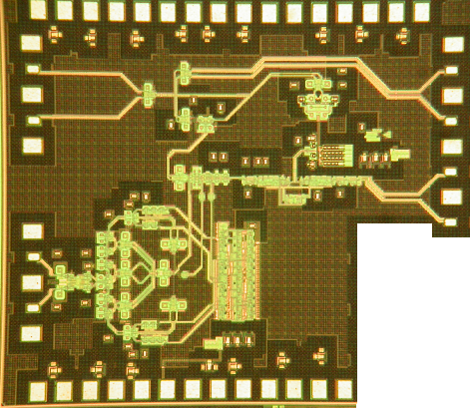

Figure 14. Die photo of the 86-Gb/s transmitter testchip.

Dickson and Voinigescu
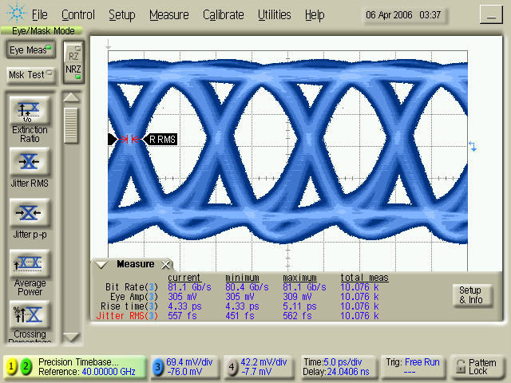

Figure 15. Measured 80-Gb/s single-ended output eye diagram with 300mV swing per side.

Dickson and Voinigescu
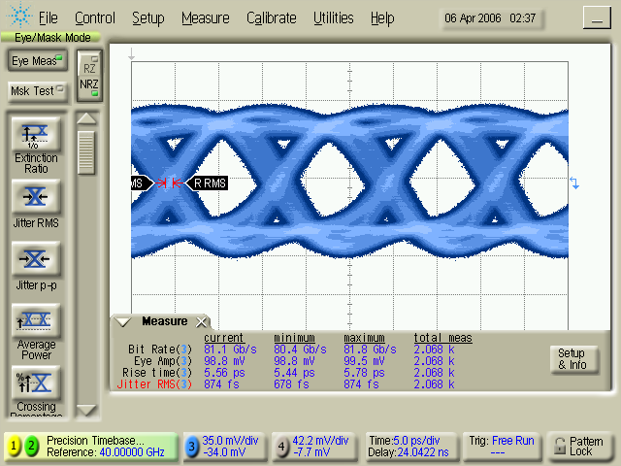

Figure 16. Measured 80-Gb/s single-ended output eye diagram with 100mV swing per side.

Dickson and Voinigescu
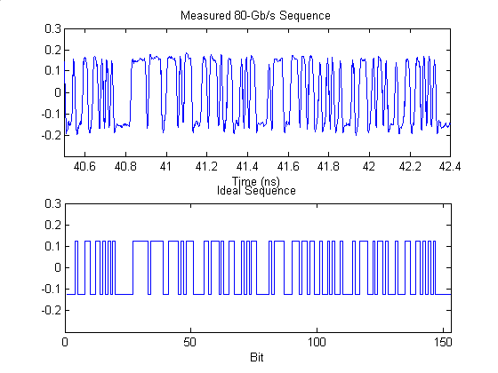

Figure 17. Measured 80-Gb/s 2⁷-1 output bit sequence and ideal output sequence.

Dickson and Voinigescu
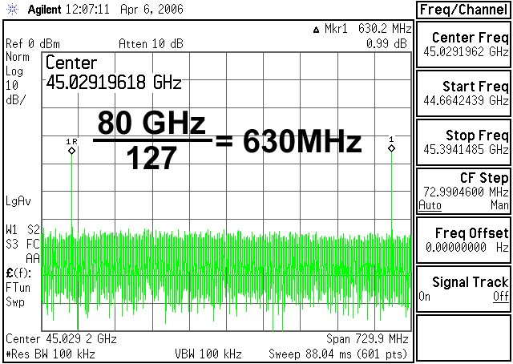

Figure 18. Measured output spectrum of the 80-Gb/s output pattern demonstrating correct PRBS multiplexing.

Dickson and Voinigescu
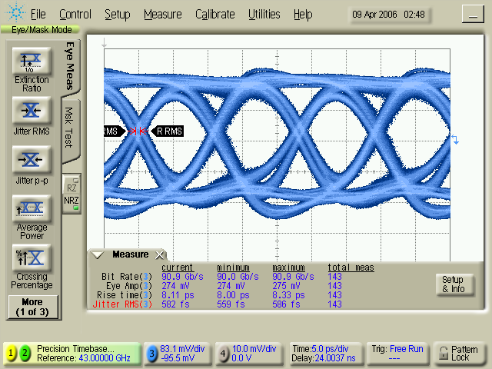

Figure 19. Measured output eye diagram at the maximum room temperature output data rate of 86-Gb/s.

Dickson and Voinigescu
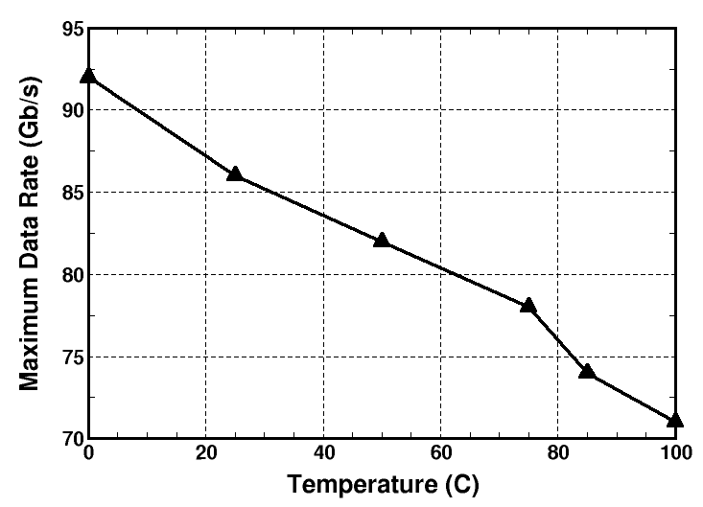

Figure 20. Maximum output data rate as a function of operating temperature.

Dickson and Voinigescu

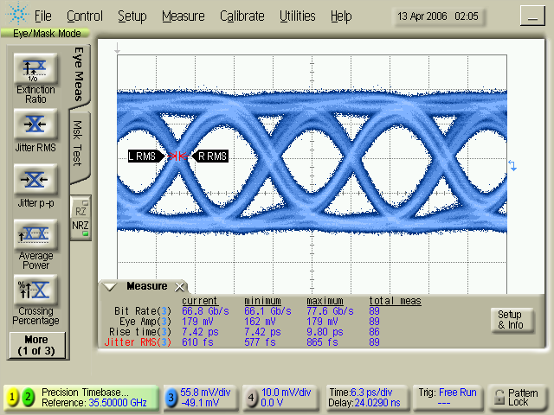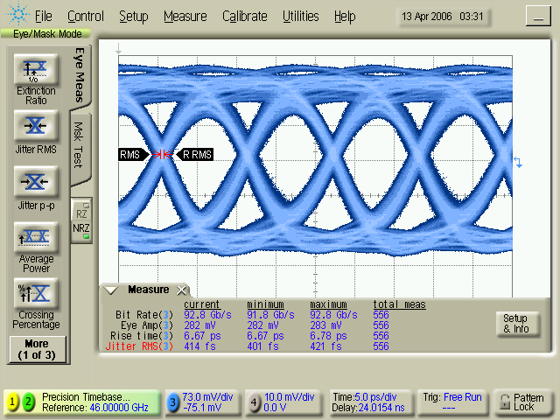
(a) (b)

Figure 21. Measured output eye diagrams over temperature variations (a) 71 Gb/s at 100ºC (b) 92 Gb/s at 0ºC.

Dickson and Voinigescu

